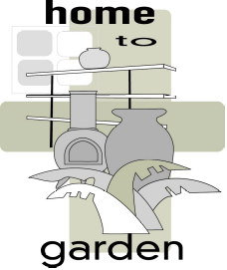
HOME TO GARDEN LTD

8A LOWER ROAD CHORLEYWOOD HERTS WD3 5LH
TEL/FAX: 00 44 1923 467372 MOB: 00 447980 893605
Email: home2gardenltd@yahoo.co.uk
Website: www.home2garden.co.uk

SELLING WIND DANCERS

The key is presentation and the number one way to keep up sales is to keep the wind sculptures turning! This is why we provide a fan for each wind dancer display stand. If positioned along the corridor, near a power point on one of the pillars, you will ensure maximum attention to your new product. Just watching them turn gently (the fan should never be turned on higher than number 1) seems to mesmerize the customers and they can’t help but want one!

When setting up the stand, make sure the larger ones are in the middle as they are the most eye catching, the smaller shapes at the top and a mixture of the large and medium at the bottom. Ensure the strings are untied from the product and the bags removed from the crystals. The crystals are of the very highest quality, 30% lead and are Austrian. Another point when building the display is to make sure all wind dancers can spin freely and not bump into each other. The top rung can take two on each pole, the middle rung should only have one each. The bottom rung can perhaps fit a mini and a medium on each pole but try not to over crowd it.
The stainless steel should be displayed preferably with the SS and the copper with the copper. Some outlets mix them though on the stand.

REMEMBER

- Keep the sculptures turning (No.1 speed on the fan)

- Do not overcrowd, all for the Wind Dancers to turn freely

- Place in a spot that gets sufficient light

- Make sure crystal are out of bags and ties are undone

- All products should have sales tags attached

